
Relational Databases with MySQL Week 4 Coding Assignment
Points possible: 70
Category | Criteria | % of Grade
Functionality | Does the code work? | 25
Organization | Is the code clean and organized? Proper use of white space, syntax, and consistency are utilized. Names and comments are concise and clear. | 25
Creativity | Student solved the problems presented in the assignment using creativity and out of the box thinking. | 25
Completeness | All requirements of the assignment are complete. | 25

Instructions: Using a text editor of your choice, write the queries that accomplishes the objectives listed below. Take screenshots of the queries and results and paste them in this document where instructed below. Create a new repository on GitHub for this week’s assignments and push this document, with your Java project code, to the repository. Add the URL for this week’s repository to this document where instructed and submit this document to your instructor when complete.
Coding Steps:
Write 5 stored procedures for the employees database.
Write a description of what each stored procedure does and how to use it.
Procedures should use constructs you learned about from your research assignment and be more than just queries.

Screenshots:
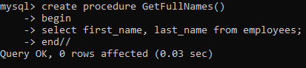
Query 1
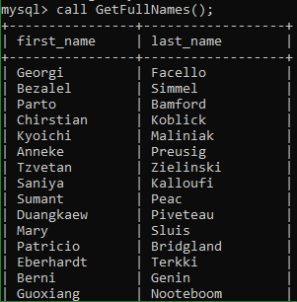
Query 2
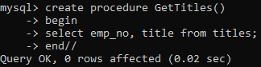
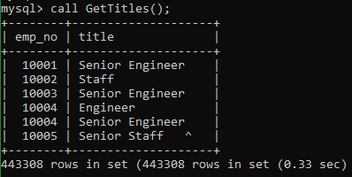
Query 3
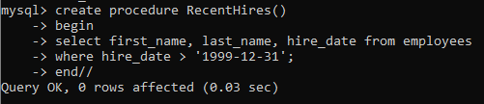
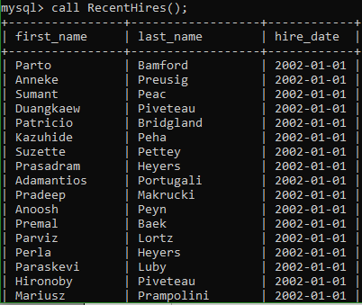
Query 4
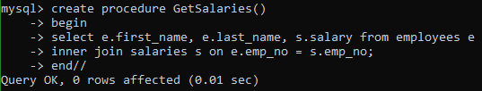
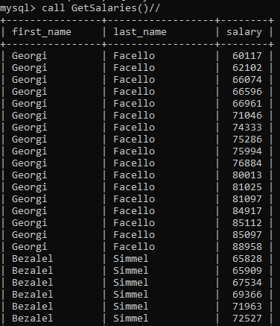
Query 5
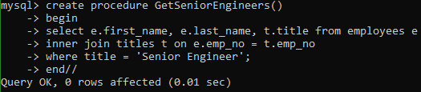

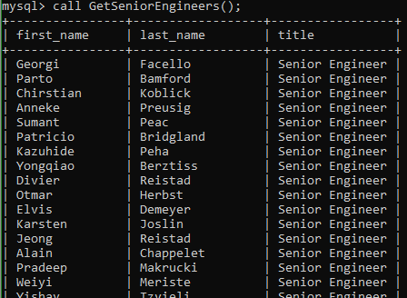
URL to GitHub Repository:

